bielomatik: Retrofit of central lubrication at BurdaDruck, Offenburg

A Swabian success story in Baden
bielomatik is expanding service availability at BurdaDruck: almost all of Burda's printers now work with lubricating systems produced by the Swabian company. The most recent success involved the replacement of two older competitor lubricating systems in Plant 1 in Offenburg with a custom-designed six-circuit lubricating system, which bielomatik developed and installed together with BurdaDruck as part of a retrofit project.
“Because we print many weekly periodicals including Focus, Bunte and Freizeit Revue, we must be able to rely on these machines,” explains Wolfgang Kienzle, project manager and technical coordinator at BurdaDruck GmbH in Offenburg. “We work in line with the publication date for each periodical.” Commercial success absolutely depends on the productivity of the printing house; a single technical fault can have a huge impact. As well as control, central lubrication – which is responsible for the majority of the lubricating tasks in a typical printing house – plays a major role in the printing process.
Burda printing houses in Europe are now equipped almost exclusively with lubrication technology from bielomatik Leuze GmbH + Co. KG in Neuffen. Now that the retrofit in Plant 1 in Offenburg is complete, ten of the total of eleven Burda printers have a bielomatik central lubricating system. Ottmar Weber of bielomatik's on-site service team was responsible for overseeing the extensive retrofit, which involved replacing the existing technology with custom-made solutions (and included replacing components that no longer worked). He was a key player in the project's development and implementation. Two lubricating systems that were no longer working have been replaced by a six-circuit lubricating system at the folder units of two printing machines. The long-serving experts redesigned every aspect of the lubrication system, as well as carrying out modifications. Now, all fault messages can be read off at the controller (an in-house development) which electronics specialists from BurdaDruck have connected to the printing machine electronics via an interface. To make it easier to analyse faults, Weber installed pressure indicators at the main distributors of the various lubrication circuits. This first major project involved laying 160 m of steel piping (18 mm diameter) and 100 m of supply and return lines in order to supply grease to each of the 500 lubricating points on the various folder units. A lubrication cabinet designed specifically for BurdaDruck was also installed in Plant 1 to supply the six-circuit system with grease via three pulse generators.
“With regard to the costs associated with materials, personnel resources and downtimes, the retrofit should pay for itself within one to two years,” says project manager Kienzle. “I can already sense the high production reliability, which I feel very strongly about because it is crucial to meeting deadlines – the ultimate priority for any publishing house. The few faults and problems we do encounter can now be rectified quickly and easily.”

BurdaDruck GmbH, Offenburg
The media centre in Baden is the largest print site in the Hubert Burda Media organisation and one of the most modern print centres in Europe. Data for 600 million pages of printed matter is processed here every day. BurdaDruck has sites in Offenburg (two plants) and Nuremberg in Germany, in Vieux-Thann in France and in New Delhi in India, where it uses gravure printing to produce high-quality periodicals, catalogues and printed advertising materials for mass circulation. As well as Hubert Burda Media publishers, its customers include independent publishing and print customers from a variety of sectors. As one of the largest printing companies in Europe, BurdaDruck is a one-stop shop which uses cutting-edge technology for everything from reproduction to print and beyond to downstream processing.
www.burda-druck.de
Approx. 3800 characters (incl. spaces)
Author: Nikolaus Fecht for bielomatik
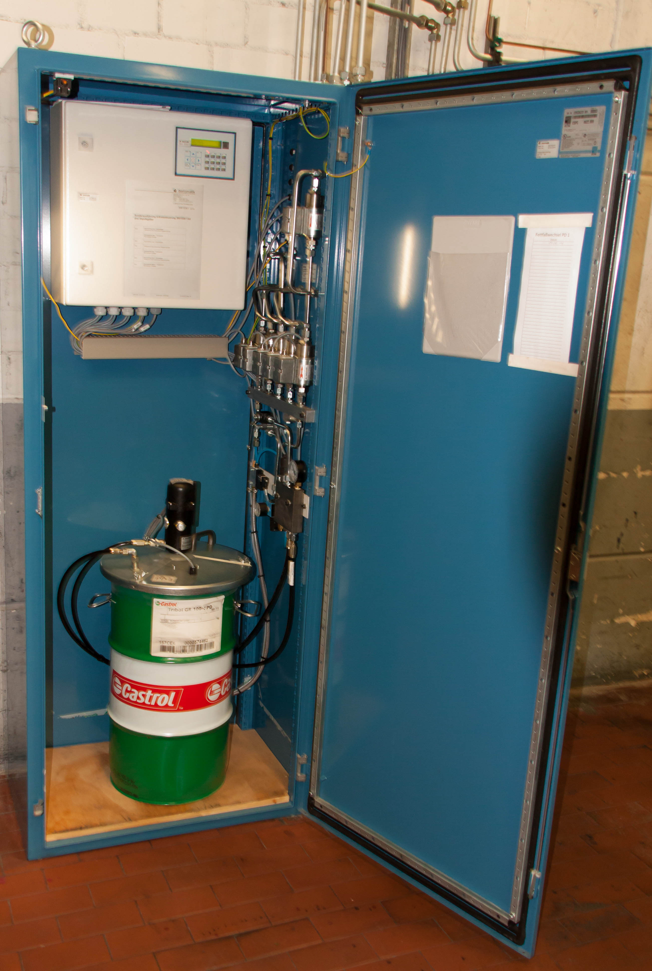
Custom lubrication: A lubrication cabinet designed specifically for BurdaDruck supplies the six-circuit system with grease with the assistance of three pulse generators. Image: Fecht

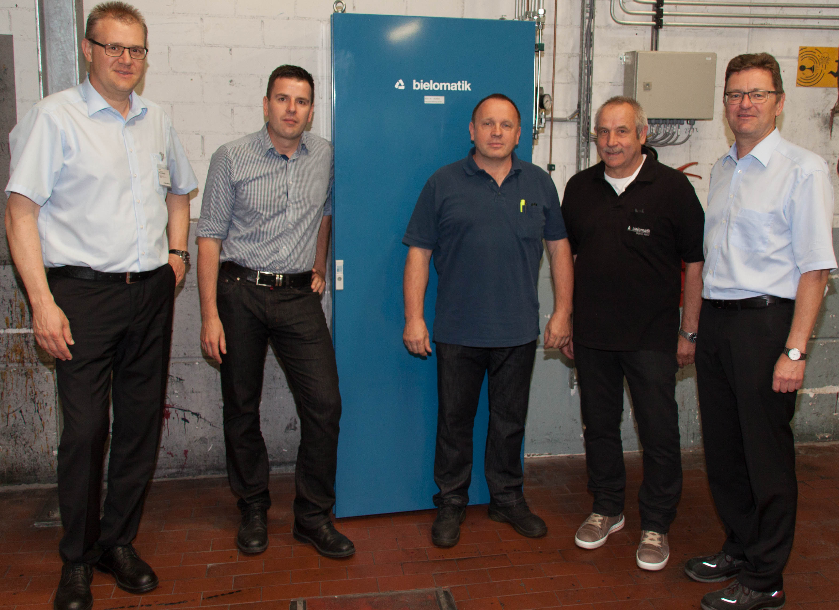
A partnership based on trust: in attendance at a meeting following the successful completion of the project to retrofit the central lubricating system were BurdaDruck employees Wolfgang Kienzle and Klaus Kaltenbach (centre) and bielomatik experts Frank Müller (left), Ottmar Weber and Hans-Peter Euchner (right). Image: Fecht

Please send questions, documents / links to:
Carolin Nuffer
Marketing - Communication
Tel.: +49 (0)7025 / 12-478
Carolin.Nuffer@bielomatik.de

Short profile:
bielomatik Leuze GmbH + Co. KG
Founded: 1946
Employees: 350

Minimal quantity lubrication systems: Technologies for sustainable and environmentally-friendly production in metal-cutting processes.

Lubrication systems: Units for precision-dosage central lubrication of machines.

Machines for welding and processing plastic: Heat element, infrared, gas convection, vibration and laser welding machines. Toolmaking. Automation technology.

