Efficient precision grinding of machine components with bielomatik minimal quantity lubrication (MQL)

Reducing energy and lubricants in the automotive industry
In mechanical engineering, maximum precision is required for the final machining. Therefore in order to ensure the quality of the workpieces, it is important that as little frictional heat as possible is created and the unavoidable rash is removed. BINE project information brochure (03/2013) “Energy efficient finishing in mechanical engineering” presents a grinding process for the automotive industry that requires minimum amounts of lubricants and coolants. In comparison with the previously standard flood cooling, the new process halves the energy consumption.
The new process, called minimum quantity lubrication, has been tested for the first time on an industrial scale on the camshaft production line at Volkswagen AG’s factory in Salzgitter. The developers optimised the grinding machine, abrasive body and the lubricant feed. The aim was to create no more frictional heat than can be removed via the tool and chips without damage. For this purpose the manufacturing process for the grinding media was changed, whereby it was furnished with a lasered, microstructured surface. The lubricant is now sprayed on via a 2-channel minimal quantity lubrication system by bielomatik. This enables the compressed air and lubricant to be optimally mixed.
The manufacture of camshafts provided a natural choice as a pilot application because the induction-hardened chromium steels, workpiece geometry and the required precision are very demanding. The new process can also be transferred to other production processes.
The previous results have been very promising. With the two million camshafts produced at Salzgitter every year, the electricity consumption during their production can be reduced by at least 2.4 million kWh. This contrasts with the minimal additional investment.
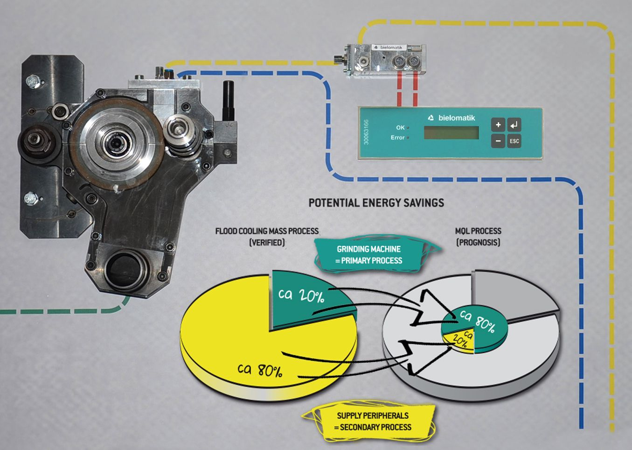
Function and potential energy savings of grinding with MQL – Image bielomatik
Nassabscheide/wet separator
Druckluft/compressed air

EMO 2017 – Hall 6, Booth H15

bielomatik Leuze GmbH + Co. KG
Daimlerstraße 6-10
72639 Neuffen
Phone: +49 7025 / 12-0
www.bielomatik.com

Questions, versions / links to:
Carolin Nuffer
Marketing Lubrication Technology
Phone: +49 7025 / 12-478
Carolin.Nuffer@bielomatik.de

