bielomatik: Retrofit pilot project on the Swabian Alb

The Stone Age has a Future

With this slogan, the gravel distribution company SVA on the Swabian Alb is promoting an industry that is currently booming – not least because there are so many road construction projects in Germany at this time. But for the project to run smoothly, it lives or dies on its production equipment always being operational, and thus on its automated lubrication. How this all works is demonstrated by bielomatik’s retrofit pilot project.
It’s about gravel, that is about aggregates, mixtures and additives for construction projects of all kinds. Located on the Swabian Jura, SVA produces several thousand tons per day from White Jura rock for customers from the Greater Stuttgart area. But the end products – finely ground – are also found in toothpaste or animal feed (calcium). In the complex manufacturing processes, the lubrication systems in the two ballast works play an important role; they were installed by the company bielomatik Leuze GmbH + Co. KG from nearby Neuffen. Schotterwerk Bauer received a new plant for the BHS mixing plant, Steinbruck Moeck received lubrication system for its BHS mixing plant and the binder + co received screening plants. Toni Pranghofer, Operations Manager at Alfred Moeck KG in Lenningen explains, “What spoke for bielomatick was both the proximity to the location and the good experience of Bauer has had with a retrofitted bielomatik lubrication system several years ago. In addition, we want to have the same technology in both plants. So it makes it easier for us to store spare parts, which is now more uniform.”
With this solution, bielomatik is breaking new ground because the company had not yet carried out any retrofit projects in this sector. “Similar to the printing industry, where we are well established, there is a particularly harsh, dusty environment here,” explains Frank Müller, Service Manager of the Lubrication Systems division at bielomatik. “However, the amount of dust is much higher here. The main sticking point is the high temperature fluctuations in the unheated buildings, which is why heated pipes are used.” Pranghofer continues, “Therefore, we do not need special lubricants for wintery conditions. As a result, we can use the same grease in all systems as far as possible.” In progressive lubrication systems from bielomatik, SVA uses mainly supple long-life lubricating greases.
The older manual lubrication systems from other manufacturers were converted to the automatic bielomatik systems without having to stop production during operation. “Only a few measures took place in the evening after the end of the operation or even on the weekend,” says the manager. In a total of 380 working hours, bielomatik service technician Oliver Oswald equipped the systems with the most diverse products from the portfolio of central lubrication from bielomatik, while the operations manager coordinated the cooperation with his own people; among other things Oswald installed control systems, pneumatic drum pumps, pipes, electric impeller pumps, distributors and fittings. In the pilot project, a total of 300 meters of steel pipe was laid in order to supply various bearing points with grease at the 80 lubrication points. But Pranghofer took care of some things on his own. In the neighboring Schotterwerk Bauer, he saw a solution that he also had installed: The electronic control cabinets were equipped with dust-proof glass control windows, so that employees can check the status of the displays at a glance – without letting the ubiquitous dust get in the cabinet.
These are not standard solutions because the degree of lubrication required depends on the location. Some bearing points receive 80 grams of grease per day, some just a few grams per week. “Oswald has teamed up with plant manager Pranghofer to then determine the grease requirements based on the data from the individual bearing points and the manufacturer's lubrication plans,” explains Müller. “The whole thing is like a tree: The pump is the root from which our system branches off to the individual lubrication points.” Using this information and that provided by the plant manager, the service technician has completely planned the plant’s lubricant systems.
The close interaction of the service technician with the customer has proved to be particularly successful for customized solutions: In one case, the supervisor only wanted to connect one sieve system to the lubrication system, but Oswald recommended that there should be a connection for all adjacent storage locations, e.g. of conveyor systems. Pranghofer says, “Now, the new plant is fully supplied with lubricant from two bielomatik systems automatically.” What speaks for this form of continuous lubrication is the longer service life of the machine, the reduced time required for personnel deployment and the lower number of failures and malfunctions.
Moeck provided the electrical control of the pump and the integration into the entire control system. “In our plant control system, there are now two windows that indicate whether the lubrication is running or not,” adds Pranghofer. “I only get a simple error message on the screen, but it is sufficient. Because then a technician goes to the plant and fixes the malfunction.” The company cannot say if there are any positive economic consequences, but the customer’s satisfaction is reflected in a pending new installation: Service technician Oswald will soon move in again to connect the so-called jaw crusher (machine for shredding very large pieces of rock) to the automatic grease supply by bielomatik.

Author: Nikolaus Fecht on behalf of bielomatik

Alfred Moeck KG, Lenningen
Founded in 1947, the company has developed into a large and effective quarry and ballast plant that supplies the Greater Stuttgart area with products made of the material “White Jura.” Along with the neighboring gravel plant Jakob Bauer Söhne GmbH & Co. KG, Moeck founded the joint gravel distribution company Vordere Alb GmbH & Co. KG (SVA) in the municipality of Erkenbrechtsweiler in 2006, which has since united both companies under one roof. www.moeck-kg.de

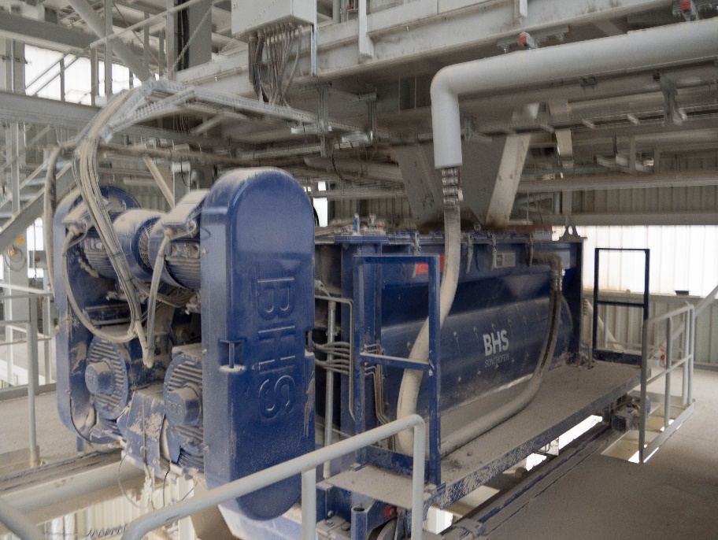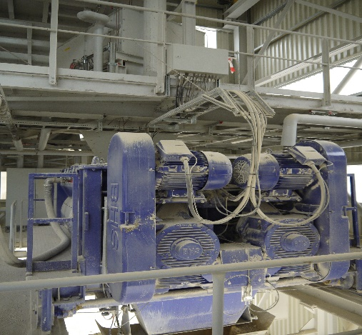
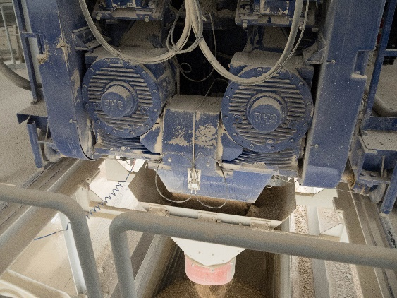
Uniform: After a retrofit by bielomatik, the Swabian quarry company SVA uses the same automatic lubricant systems at the industrial mixer in both of its plants.
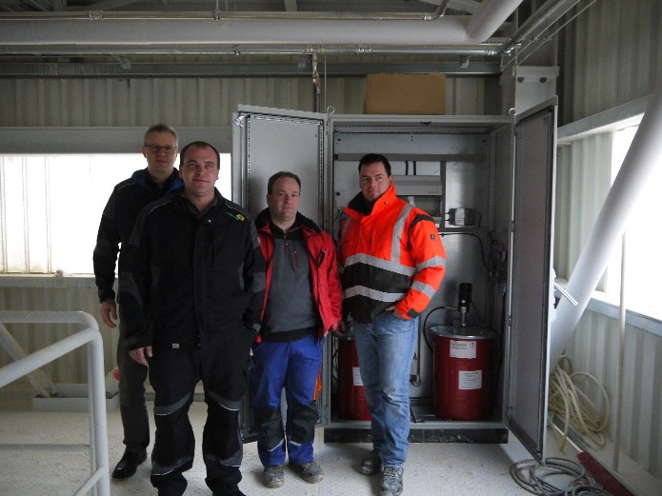
Group picture with supply cabinet (from the right): Moeck plant manager Toni Prangshofer and SVA electrician Steffen Buck work closely together with lubricant technicians Oliver Oswald and Frank Müller.
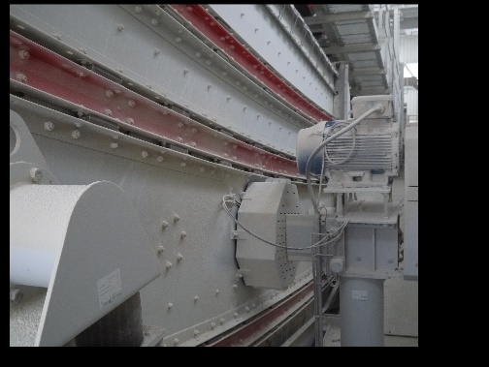
Extended: Not only mixing and screening equipment, but also conveyor technology is centrally lubricated with bielomatik technology.
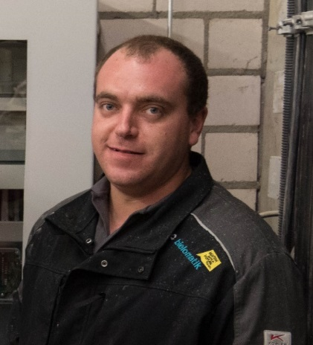
The man on location: bielomatik service technician Oliver Oswald has planned and installed the lubrication systems based on the information provided by the machine manufacturer and by the operations manager at Moeck.
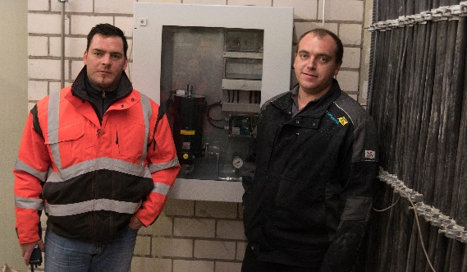
Transparent: Moeck plant manager Pranghofer and bielomatik service technician Oswald in front of one of the electronic control cabinets with dust-tight inspection windows made of glass.
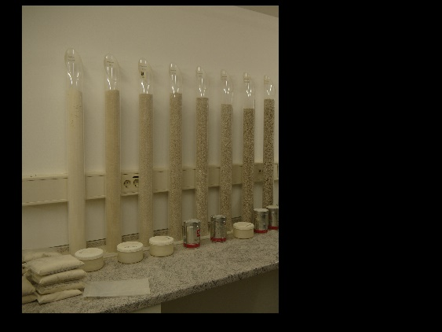
The "Grinder": Products are made from the raw material White Jura according to customer requirements in the Moeck quarry – from rock aggregates, mixtures and additives for construction projects all the way to the finest ground stone powder for toothpaste.
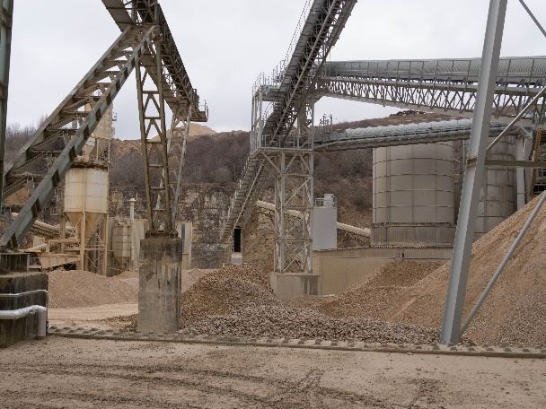
Stone age with a future: The SVA in the Swabian Alb (pictured: SVA Moeck) produces more than 8,000 tons and more per day from White Jura for customers from the Greater Stuttgart area.
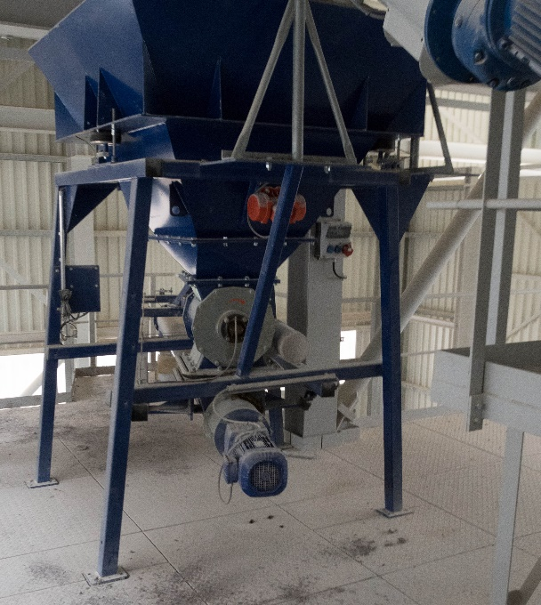
Connected: The retrofit from bielomatik at the quarry company SVA (pictured: a scale for aggregates in the Moeck plant) unified and automated the lubricant supply.
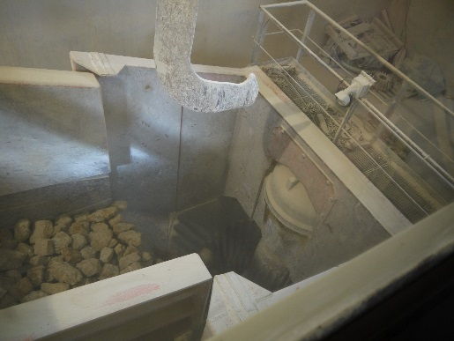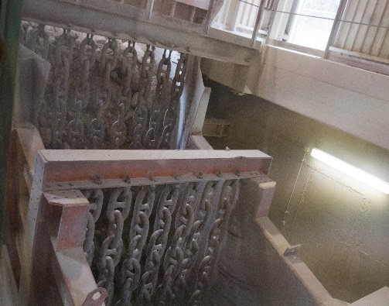
Retrofit in sight: Soon bielomatik will be back in order to connect the so-called jaw crusher to the automatic grease lubrication system from bielomatik.
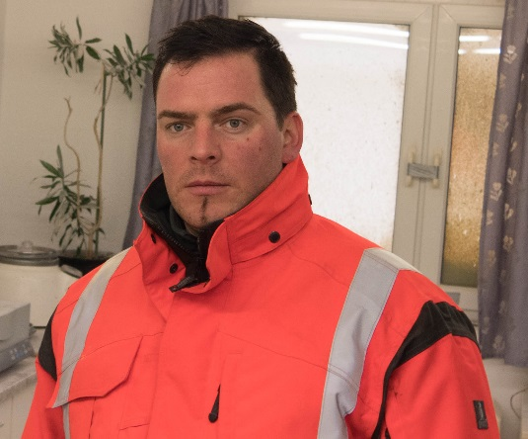
Toni Pranghofer, Operations Manager at Alfred Moeck KG in Lenningen: “The proximity to the location and the good experience of the Bauer gravel works spoke in favor of bielomatik. In addition, we want to have the same technology in both factories. Doing this also makes it easier for us to store spare parts, which is now more uniform.”

Pictures: bielomatik/Nikolaus Fecht

bielomatik Leuze GmbH + Co. KG
Daimlerstraße 6-8
72639 Neuffen
Phone: +49 7025 / 12-0
www.bielomatik.com

Questions, versions / links to:
Carolin Nuffer
Marketing Lubrication Technology
Phone: +49 7025 / 12-478
Carolin.Nuffer@bielomatik.de

