K 2016 Düsseldorf, October 19th – 26th 2016 / hall 11 / booth G 60

World debut: laser-based infrared welding

For the very first time, this worldwide innovation is presented to an expert audience at the K 2016. Again, bielomatik increases its comprehensive portfolio of technically feasible welding technologies with this unique innovation. And it is the only company worldwide providing laser-based infrared welding.

The new technology combines the advantages of the well-known, robust two-step infrared welding of mechanical engineering with the quasi-simultaneous laser-based welding. Inside the separate periods of heating and joining, the joining surfaces are heated flexibly with high scanning speed before they are pressure-welded.

Numerous benefits in one production process

For users, laser transparent plastics cease to be an issue, as well as special component design for laser penetration welding and different absorption properties of plastics. And: Component alterations and tolerances are easily adjustable.

Convincing results
Laser-based infrared welding is completely particle-free, with high welding strength even with challenging structures like assembly- and insert-components, or component geometries that were unachievable with laser to date. Applications are found in the automotive industry, white goods, sanitary and installation, electrical engineering, electronic engineering, medical and pharmaceutical technology.

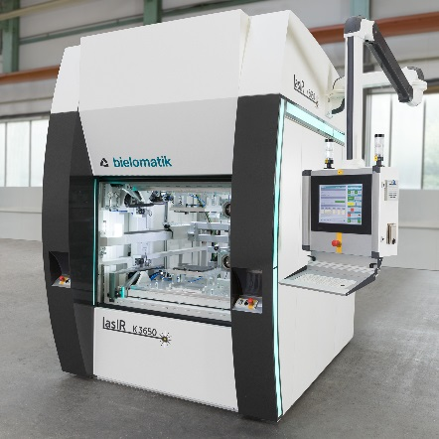
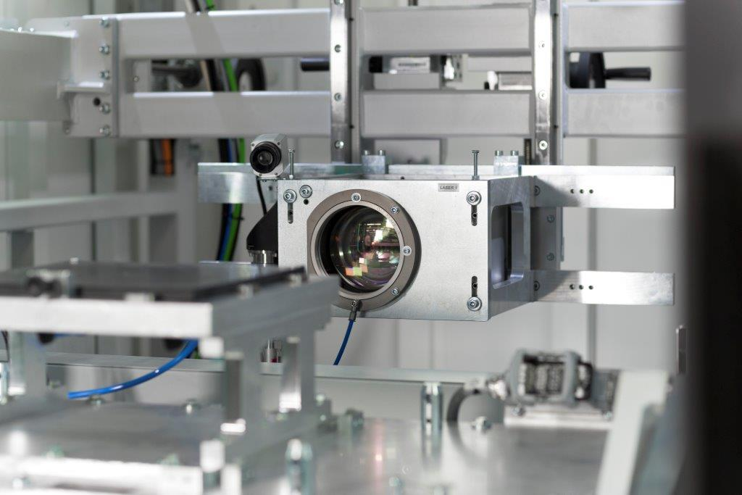
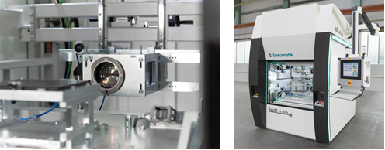

K3650 (Bilder bielomatik)

bielomatik Leuze GmbH + Co. KG
Daimlerstraße 6-10
72639 Neuffen
Germany
Phone: +49 7025 / 12-0
info-plasticwelding@bielomatik.de
www.bielomatik.de

Questions, version / links to:
Andrea Ries
Marketing - Communication – Trade Fairs
Phone: +49 7025 / 12-389
Andrea.Ries@bielomatik.de

