K 2016 Düsseldorf, October 19th – 26th 2016 / hall 11 / booth G 60

Technologically feasible. Economically viable: bielomatik system engineering for the welding of SCR-containers.

Removing nitrogen oxide emissions from Diesel exhaust gases – an absolute must for vehicle manufacturers. It’s the only way to make sure meeting future European and American emission regulations for commercial vehicles, agricultural machinery and passenger cars. All this is achieved with the Selective-Catalytic-Reduction-Method (SCR). bielomatik makes a significant contribution towards that.

bielomatik provides to producers the optimum manufacturing technologies necessary for the welding of SCR-containers used in the Selective-Catalytic-Reduction-Process. They are realised as special engineering systems for prototypes, small lot and series production. At the K you will see an exemplary automated system for demonstration. The containers are used for the storage of synthetic urea. The challenge: the creep ability of the urea, and extreme mechanical demands like frost. Such conditions require welding that is utterly reliable and dense.

Comprehensive user support
bielomatik provides complete customer support regarding all issues surrounding the appopriate automation level with the production of SCR containers. Planning is focused on the most efficient system concept, tailored specifically to the customer’s requirements, the optimum welding technology, and the necessary cycle times. The range on offer includes simple, manually operated systems, partly automated equipment, or complex, fully automated manufacturing lines. Careful consideration is applied when choosing the appropriate system, depending on criteria like available set-up area or planned production output. In many cases, the use of robots is the best choice. Systems with integrated robotics are flexibly integrated in any production site, extensions and changes are easily applied. Besides, with robotics, every user can handle his production with maximum flexibility, matching individual manufacturing demands.
The Neuffen team also puts a strong consulting focus on the construction of container geometries. In this way, process-reliable and economical weld geometries for an efficient production process can be identified even at the conceptual stage.

Taking into consideration all aspects

Urea storage and supply can be divided into four major parts: urea container, conveyor unit (pump), filter, and heater. All units can come with different designs, e.g. with separate, or integrated, pumps and filters for commercial vehicles, passenger cars, agricultural and construction machinery. The key component, however, always constitutes the urea container made of plastics, formed with various production methods like injection moulding, blow moulding, or rotational sintering. The user most often demands a container as compact as possible. To achieve this end, production methods are most suited where two or more plastic components can be joined as containers, easily integrating the respective conveyor system. bielomatik realises tailor-made systems meeting the user’s specific production requirements. Especially when accomplishing such complex applications, bielomatik relies on what really counts: high tech with a human touch, and long-standing experience in the finishing of fuel tanks and in welding of plastic components with all current welding technologies.

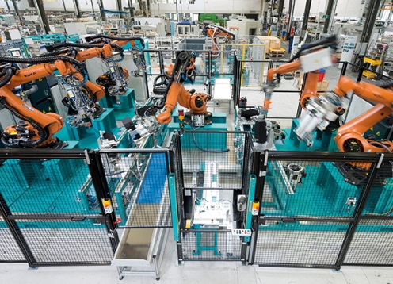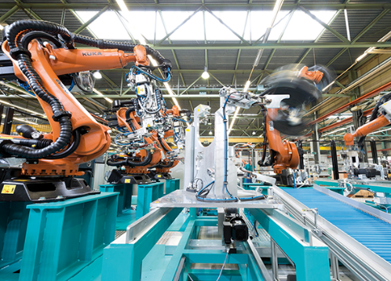
High-performance production unit for the welding of urea containers for the exhaust gas cleaning a spart of the SCR-Process, fully automated with robots. (Image bielomatik)

bielomatik Leuze GmbH + Co. KG
Daimlerstraße 6-10
72639 Neuffen
Germany
Phone: +49 7025 / 12-0
info-plasticwelding@bielomatik.de
www.bielomatik.de

Questions, versions / links to:
Andrea Ries
Marketing - Communication – Trade Fairs
Phone: +49 7025 / 12-389
Andrea.Ries@bielomatik.de

