Chinaplas, May 16th – 19th 2017

Start producing economically: with the largest portfolio for welding technology solutions.

bielomatik, with headquarters in Neuffen, Germany, is the only company developing and manufacturing machines and systems for all current plastic welding technologies.

This is an essential premise for our customers to realise a truly economic production. On the one hand, absolutely process-neutral consulting is guaranteed. On the other, the application of fully customised systems and machines is assured. This is what High tech is all about. Of course, bielomatik has much more on offer: High tech with a human touch. Our production is highly customer-focused; for many manufacturing steps, the necessary quality can only be achieved with manual work. ‘Human touch’ means we realise customer requests with greatest dedication – at every step, from consulting to the development of certain products up to global services.

Presence: around the world
Form more than 70 years bielomatik contributes to ever more economic production solutions for our customers, operating from every global representation. To this end, 590 employees are at work, 350 of which reside at the headquarters in Neuffen, the rest at locations in the U.S., Romania and China. Especially our site in Dongguan plays an ever-increasing role. The subsidiary bielomatik Machinery (Dongguan) Co. Ltd., founded 2004 as a joint venture, is gaining significantly in importance. That is displayed in the number of its employees – up to now 170. And, just as importantly, in its broad product portfolio: Dongguan from now on develops and manufactures machines and systems for laser welding, too – including: comprehensive consulting, as well as technical support and customer service.

bielomatik Machinery: First exhibition of a laser welding machine
At Chinaplas 2017, bielomatik Machinery Dongguan (BMD) will underpin its importance. For the first time, bielomatik will present a laser-welding machine at the Chinaplas. Subsequently, the machine will be available at the Dongguan plant for the development of tailormade solutions, pilot series projects, and welding process tests. Highly innovative welding technology – high tech with a human touch, by bielomatik China of course.

Laser transmission welding is an established technology with a very small heat-affected zone for small and large series. It is specifically suited for delicate small parts requiring vibration-free welding and housings containing thermally sensitive materials. Typical applications include automotive industry, home appliance and white goods industry, electrical engineering, electronics, medical and pharma technology. Application is possible in two variants: Quasi-simultaneous laser welding enables high weld strengths, as well as precise, visually perfect weld seams, therefore often used in design. With laser-contour-welding, welding of complex, three-dimensional contours is possible.

More information at the Chinaplas 2017 at the booth of bielomatik Machinery, hall 5.1A01.

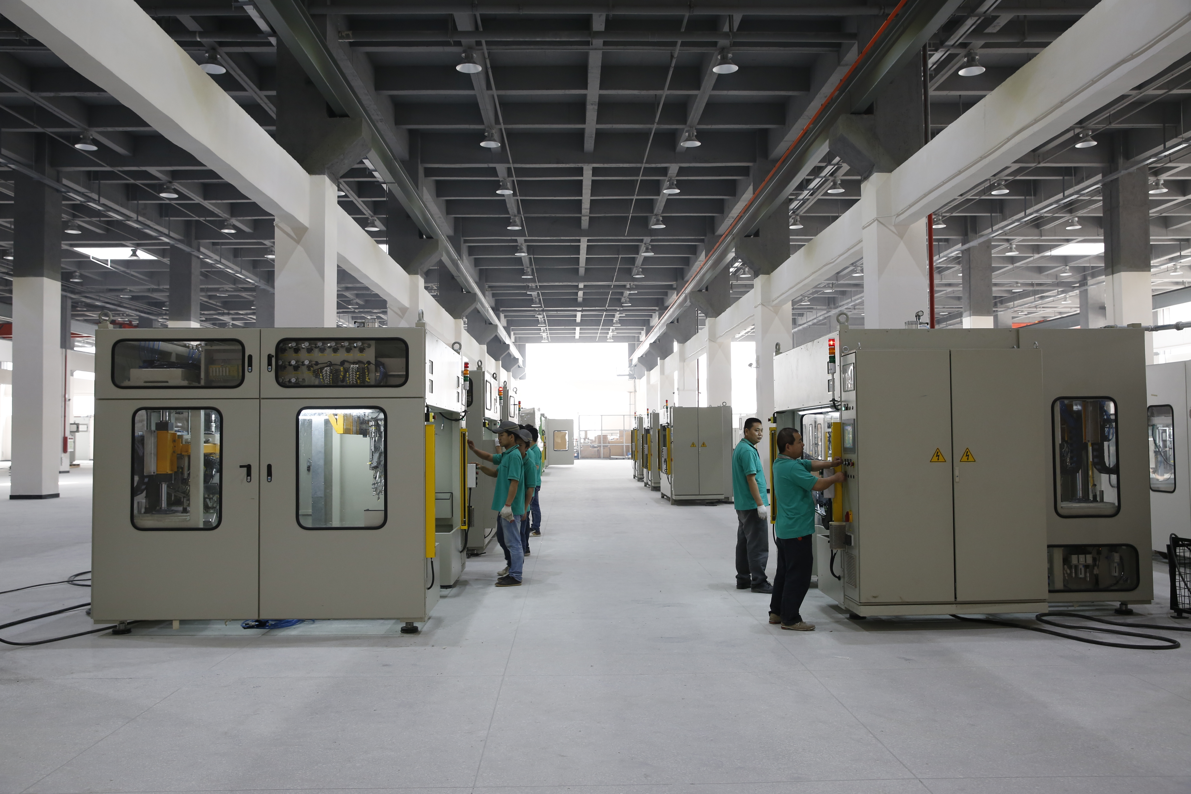

A view of the assembly hall

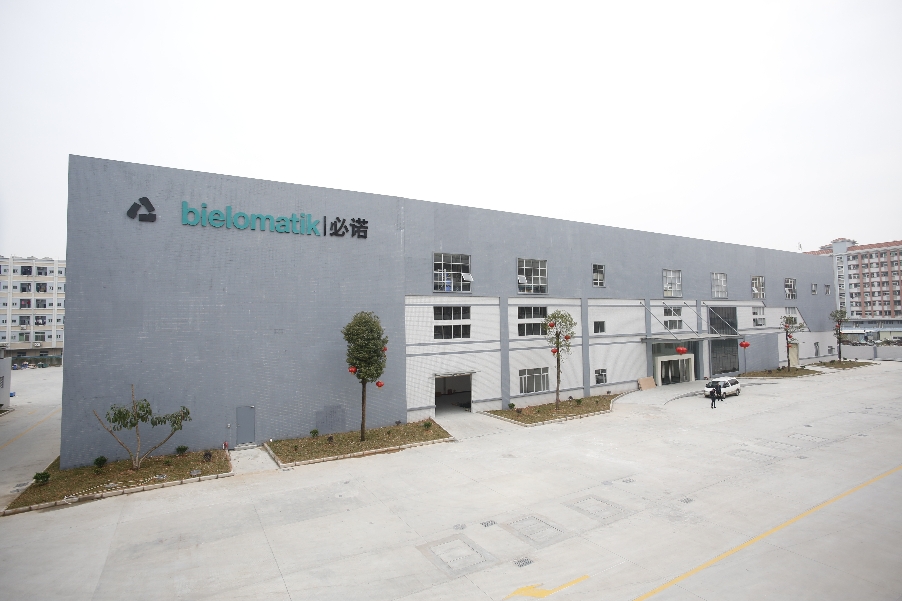

Dongguan production plant

bielomatik Leuze GmbH + Co. KG
Daimlerstraße 6-10
72639 Neuffen
Germany
Phone: +49 7025 / 12-0
info-plasticwelding@bielomatik.de
www.bielomatik.de

Questions, version / links to:
Andrea Ries
Marketing - Communication – Trade Fairs
Phone: +49 7025 / 12-389
Andrea.Ries@bielomatik.de

