FAKUMA 2017

LasIR Turn2Weld
Two-step laser welding in action

Our world debut is being shown at the FAKUMA 2017 (hall 4, booth 4111) for the second time, but this time expert audiences can view this innovative bielomatik technology in full action. The two-step laser welding has been constantly enhanced over the last year by conducting numerous test weldings. Additionally, the company from Neuffen presents its optimized Connected Services.

bielomatik is the only company worldwide offering two-step laser welding Turn2Weld. The new technology combines advantages like two-step infrared welding, known for its robustness in mechanical engineering, and the method of quasi-simultaneous laser welding. Inside the separate processes of heating and joining, the joining surfaces are heated flexibly with high scanning speed before they are pressure-welded.

Optimizing production
The method is much more user-friendly as laser-transparent plastics, special component design and different absorption properties of plastics aren’t an issue anymore. Component alterations and parts tolerances are easily adjustable. The method is completely particle-free and enables high welding strength. Housings and special component geometries, up to now unachievable, now become possible with laser-based infrared welding.

Advancing machine efficiency
At our open house day in June, bielomatik was able to demonstrate to a selected group of customers how the innovative Remote Tool Connected Services easily enhances machine efficiency. The first batch of pilot projects has successfully started, and our range of services is continually advanced and extended. The tool offers user-friendly online connection of production units while providing a wide range of services from remote diagnosis up to service history and document management. In this way, a highly effective digital support of processes and machine functionality is realized – your direct line to bielomatik.

bielomatik Leuze GmbH + Co. KG
Daimlerstraße 6-10
72639 Neuffen
Phone: 07025 / 12-0
www.bielomatik.de

Please forward any questions, documents or links to:
Andrea Rall
Marketing - Kommunikation - Messe
Phone: 07025 / 12-389
Andrea.Rall@bielomatik.de

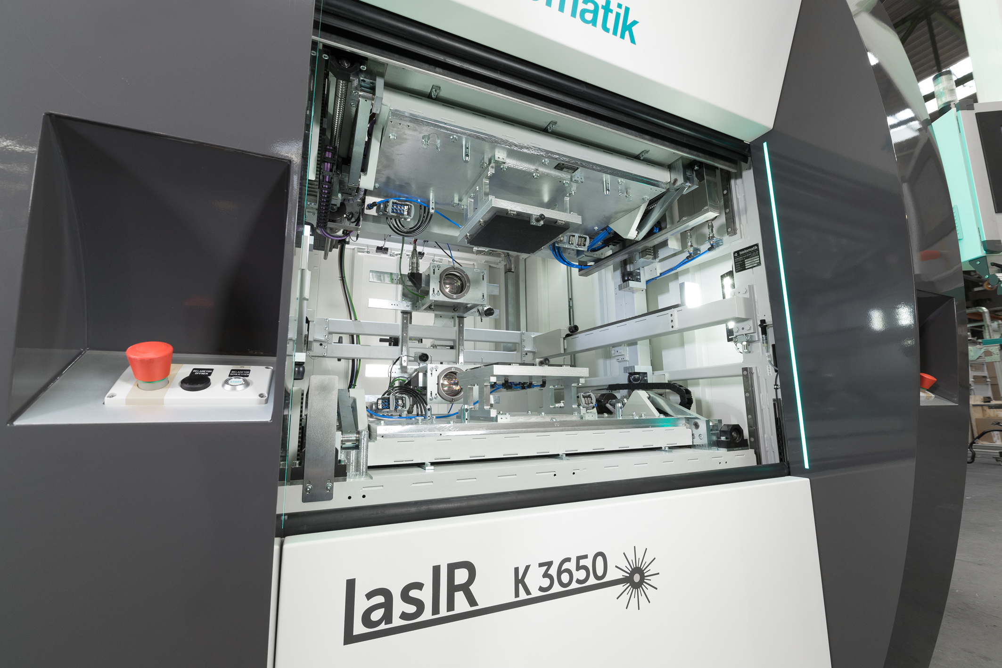

Laser-based infrared welding

