bielomatik: NEW MQL 1-CHANNEL-SYSTEM

New 1-channel-system with even more benefits

The minimum quantity lubrication technology from bielomatik enables reduced energy consumption, less water consumption, and less oil-containing waste. The 1-channel-system creates a stable aerosol which is guided through the spindle towards the tool via internal channels. bielomatik has developed and optimized this technology another step forward.

The principle of minimum quantity lubrication is highly efficient. An exact amount of oil is introduced into the cutting area of the tool. This results in an almost dry process where the heat generated is primarily dissipated via the chips.

Much more than standard
The improved 1-channel-system increases the aerosol volume in the cooling channel and can now even supply up to 80ml/h aerosol to the tool without accumulating oil. In the standard device, air pressure can be increased up to 16 bar. The automatic mode makes the system very user-friendly . It also contains an integrated control system with hardware and software interfaces for Profibus and Profinet.

Optimized lubrication technology
Four aerosol outlets enable the simultaneous supply of up to four spindles in a machine tool, providing an improved distribution of the lubricant. Furthermore, the programs can be set up for process optimization. The system utilizes an automatic refill unit, is capable of using different MQL oils and is also suitable for deep-hole drilling as well as for small tools.

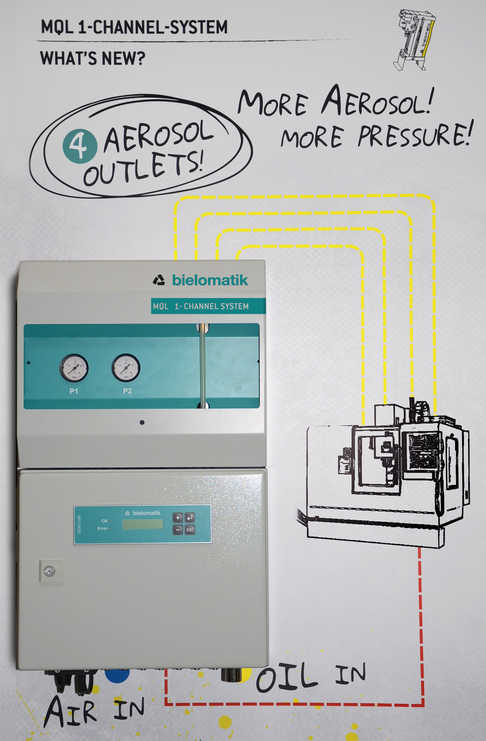
New bielomatik 1-Channel system with 4 aerosol outlets . Image: bielomatik

bielomatik Leuze GmbH + Co. KG
Daimlerstraße 6-10
72639 Neuffen/Germany
Phone: 07025 / 12-0
www.bielomatik.com

Please send any questions and comments to:
Carolin Nuffer
Marketing Lubrication Technology
Phone: ++49-7025 / 12-478
Carolin.Nuffer@bielomatik.de

