Rennteam University of Stuttgart

Manufacturing: For race cars from Stuttgart.

The Rennteam from the University of Stuttgart is the No. 1 in the global ranking of the Formula Student. The competition is a supplement of the regular curriculum. Students are able to gain comprehensive insights into the various aspects of car manufacturing.

551 teams from colleges and universities take part in the Formula Student. In the international competition with the same name, it’s all about the best solution for a racing car. The aim is not to simply cross the finish line first – the whole package counts. Besides speed, aspects like construction, financial planning and marketing matter just as much.

Commitment for two reasons
In 2016, bielomatik supported the Rennteam of the University of Stuttgart very energetically, both to do justice to our deep connection with the city and the region. And, because of bielomatik minimum quantity lubrication systems. These are employed especially with machining combustion engines and gears – components that are in use by the Rennteam, as well.

Manufacturing of wheel axles
The students design, construct and build their racing car. A little outside expertise is allowed, however, and welcome. In 2016, bielomatik took on the manufacturing of the wheel axles made from high-tensile aluminum – a challenging job, as tight tolerances have to be met accurately. An extra-large portion high-tech with a human touch and our strong identification with the team helped to achieve a satisfying solution. And now, bielomatik sends the very best wishes that after a successful 2016 comes a winning 2017, true to the motto ‘Complete, finish, win!’. bielomatik is crossing fingers for the upcoming competitions in the U.S., Spain, Austria, Germany and Hungaria!

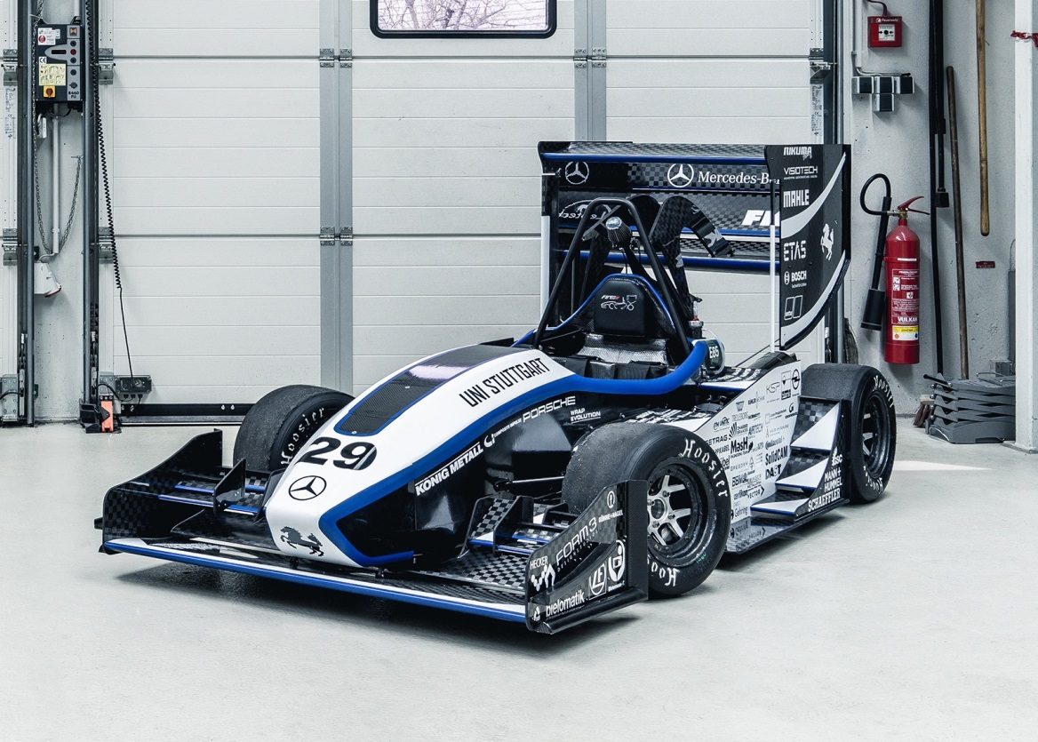

Racing car of the Rennteam of the University of Stuttgart
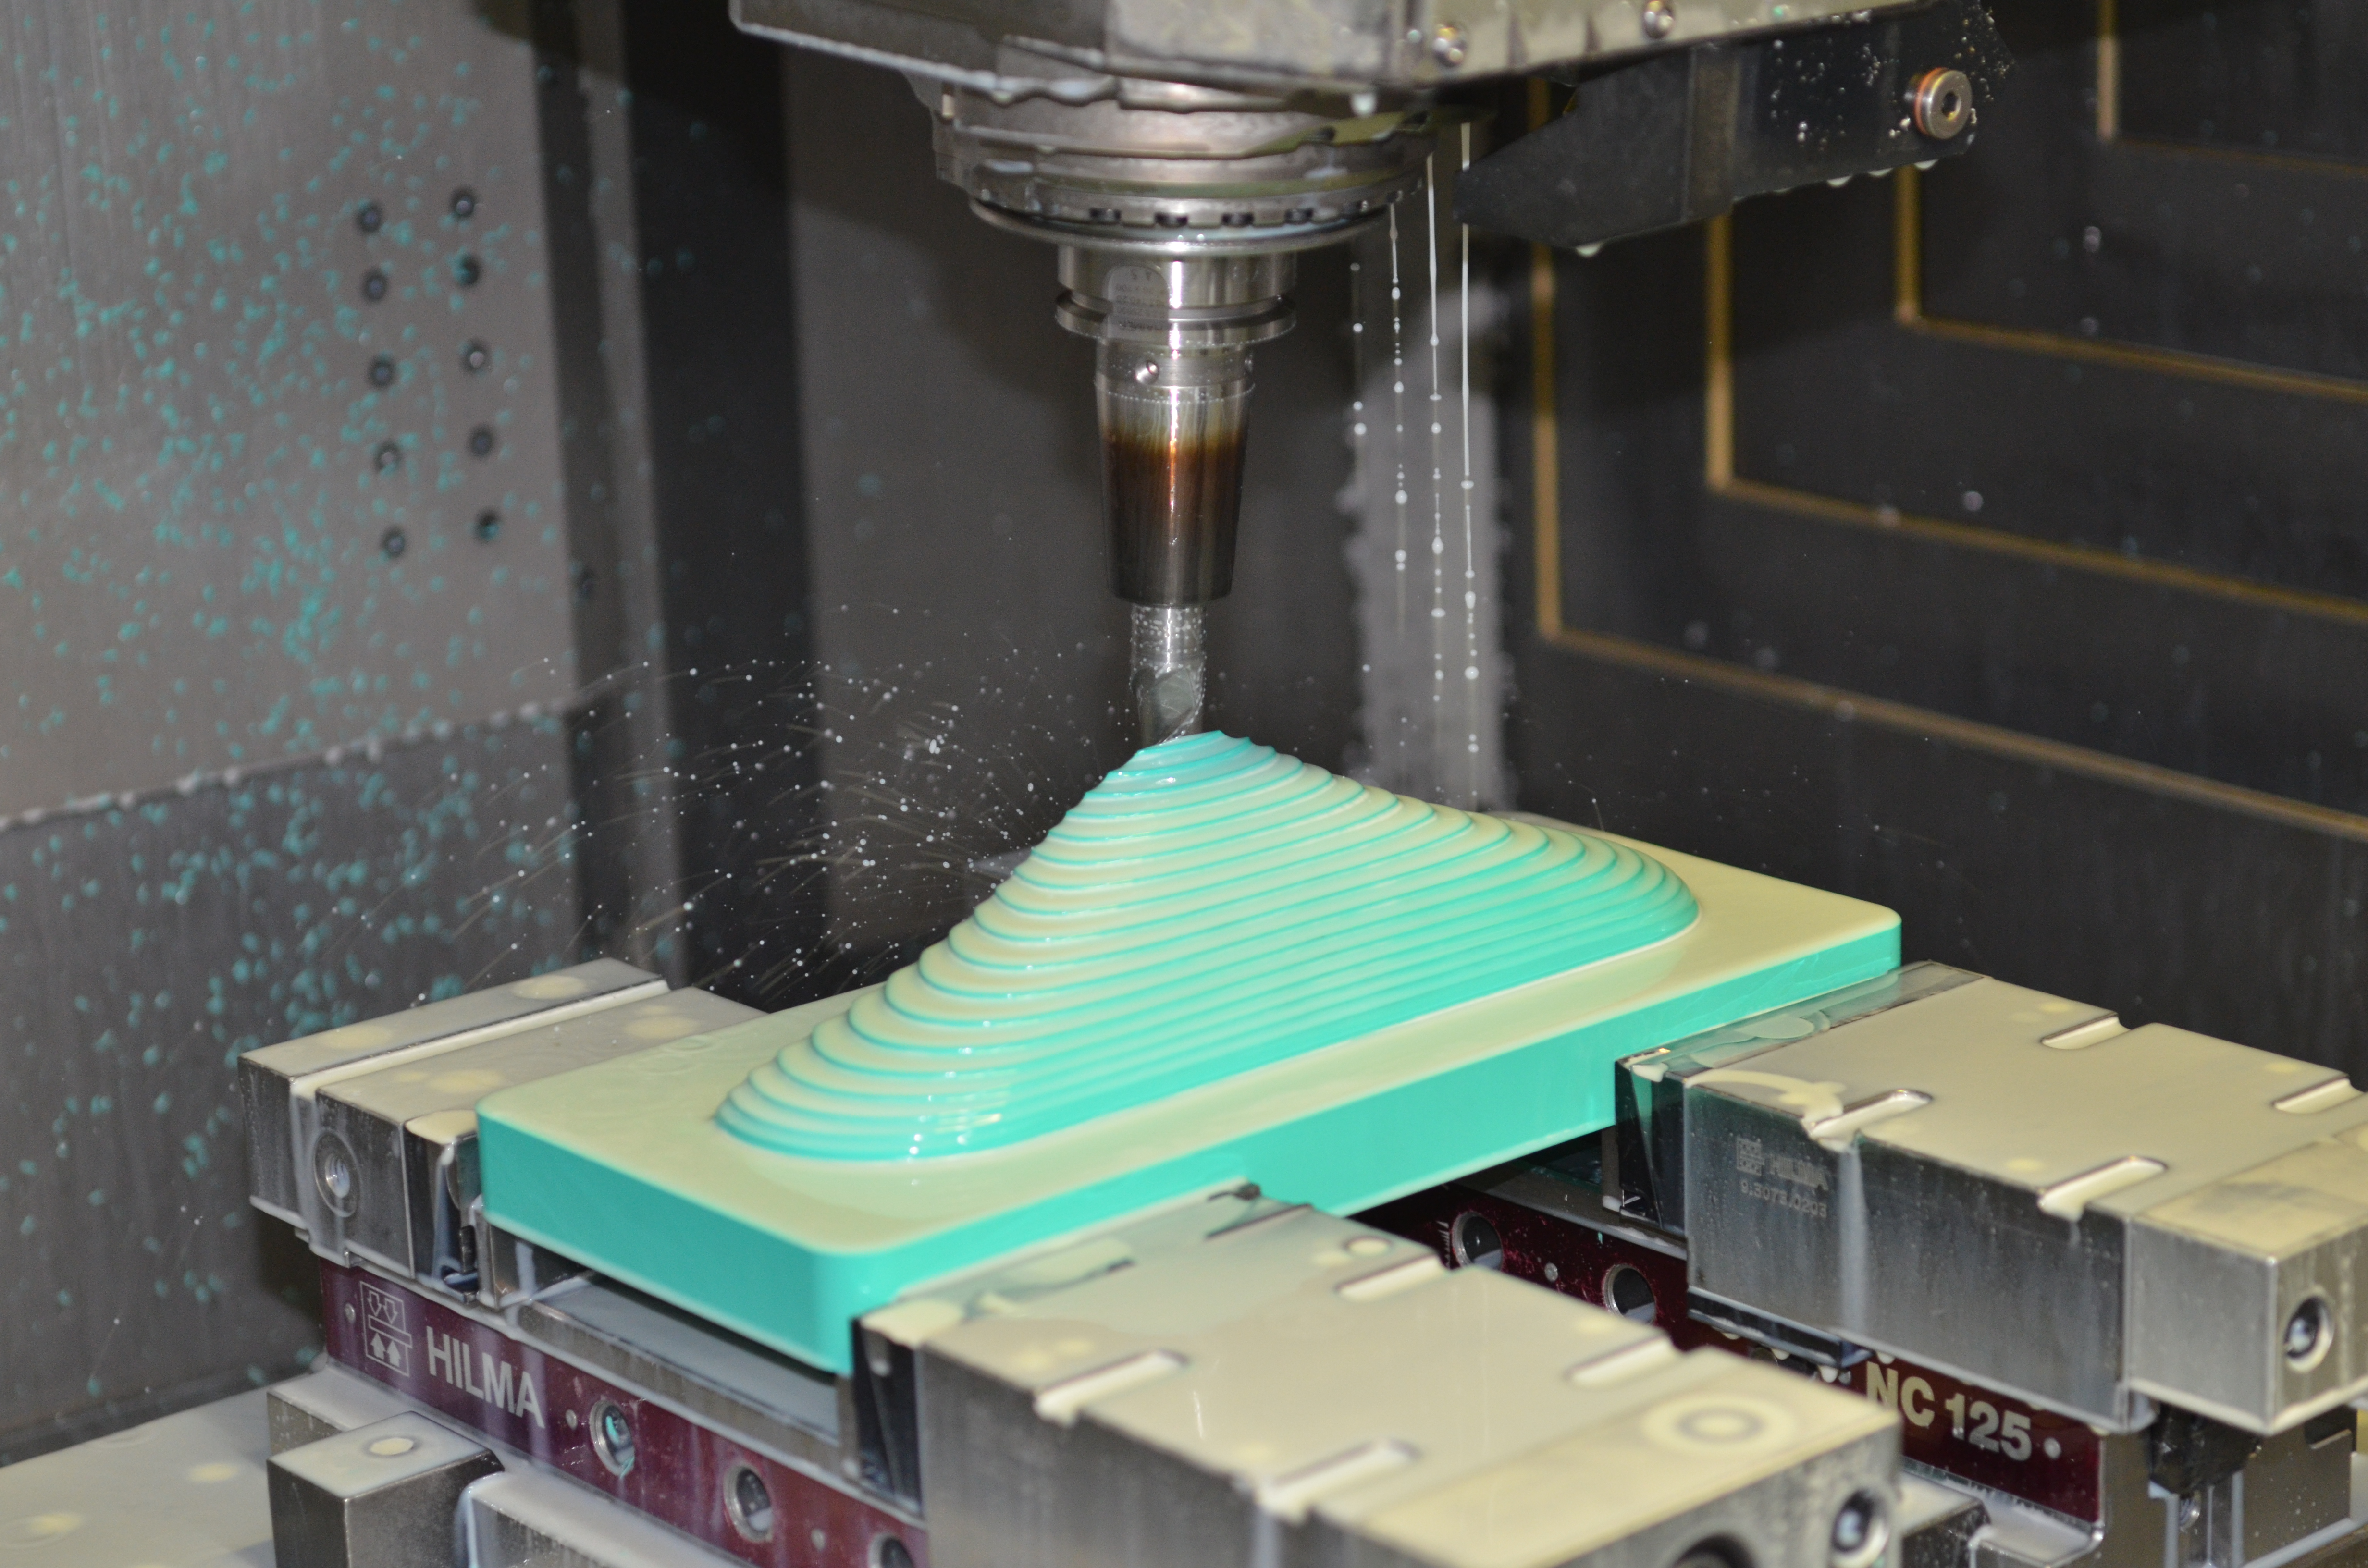

Milling of molds for carbon components of the racing car

bielomatik Leuze GmbH + Co. KG
Daimlerstraße 6-10
72639 Neuffen
Phone: +49 7025 / 12-0
www.bielomatik.com

Questions, versions / links to:
Carolin Nuffer
Marketing Lubrication Technology
Phone: +49 7025 / 12-478
Carolin.Nuffer@bielomatik.de

