FAKUMA 2017 - REVIEW

Revolution at the Fakuma?
Plastic welding turned upside down!

At the FAKUMA 2017 bielomatik boldly presented a revolution: The global novelty LasIR Turn2Weld was demonstrated in action for the first time. The two-step laser welding technology had been further developed over the last year, and successful test weldings with serial parts were performed. Additionally, the company from Neuffen introduced its optimized Connected Services.

bielomatik is the only company worldwide offering two-step laser welding Turn2Weld. The new technology combines advantages like two-step infrared welding, known for its robustness in mechanical engineering, and the method of quasi-simultaneous laser welding. Inside the separate processes of heating and joining, the joining surfaces are heated flexibly with high scanning speed before they are pressure-welded.

Providing constructive freedom
For applicants, laser-transparent plastics, special component design and different absorption properties of plastics aren’t an issue anymore. Component alterations and parts tolerances are easily adjustable. The method is completely particle-free and enables high welding strength. Housings and special component geometries, up to now unachievable, now become possible with the two-step laser welding.

Increasing machine availability
At the Fakuma in Friedrichshafen bielomatik introduced the direct line to Neuffen. With the innovative remote tool Connected Services, machine efficiency is easily enhanced. The first batch of pilot projects are running, and our range of services is continually advanced and optimized. The tool offers user-friendly online connection of production units while providing a wide range of services from remote diagnosis up to service history and document management. The reduction of on-site service further decreases costs, and by cooperating with a TÜV-certified partner, maximum data security is provided.

bielomatik Leuze GmbH + Co. KG
Daimlerstraße 6-10
72639 Neuffen
Phone: 07025 / 12-0
www.bielomatik.de

Please forward any questions, documents or links to:
Andrea Rall
Marketing - Kommunikation - Messe
Phone: 07025 / 12-389
Andrea.Rall@bielomatik.de

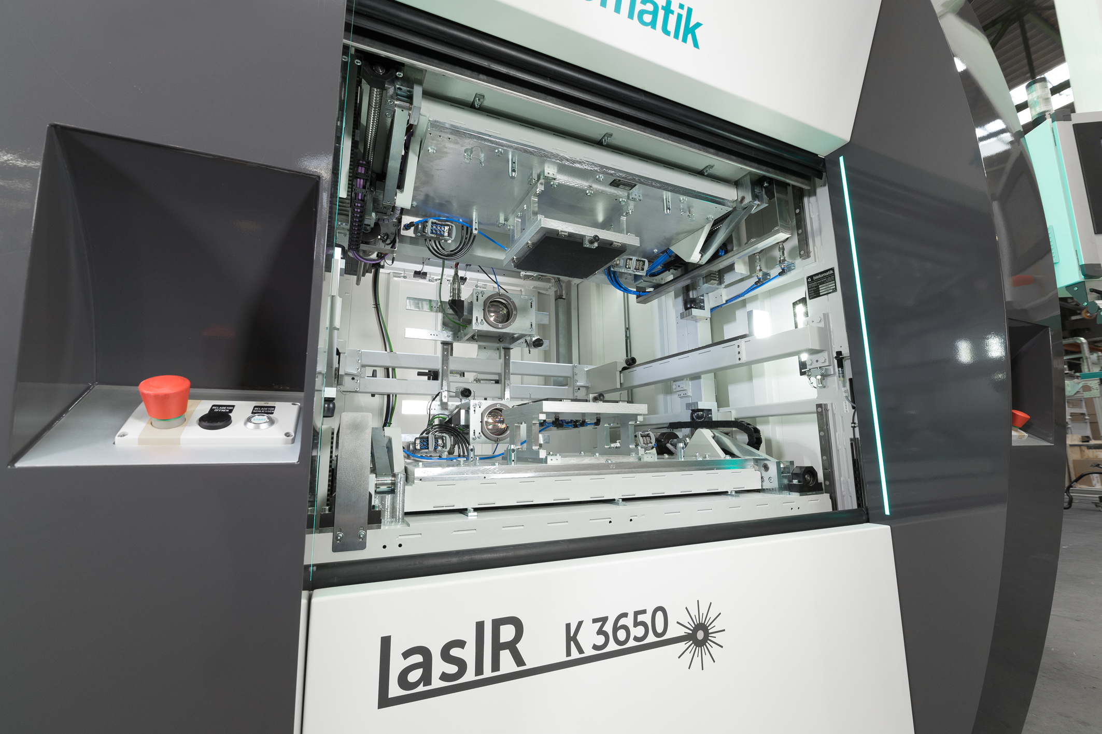

caption: Laser-based infrared welding

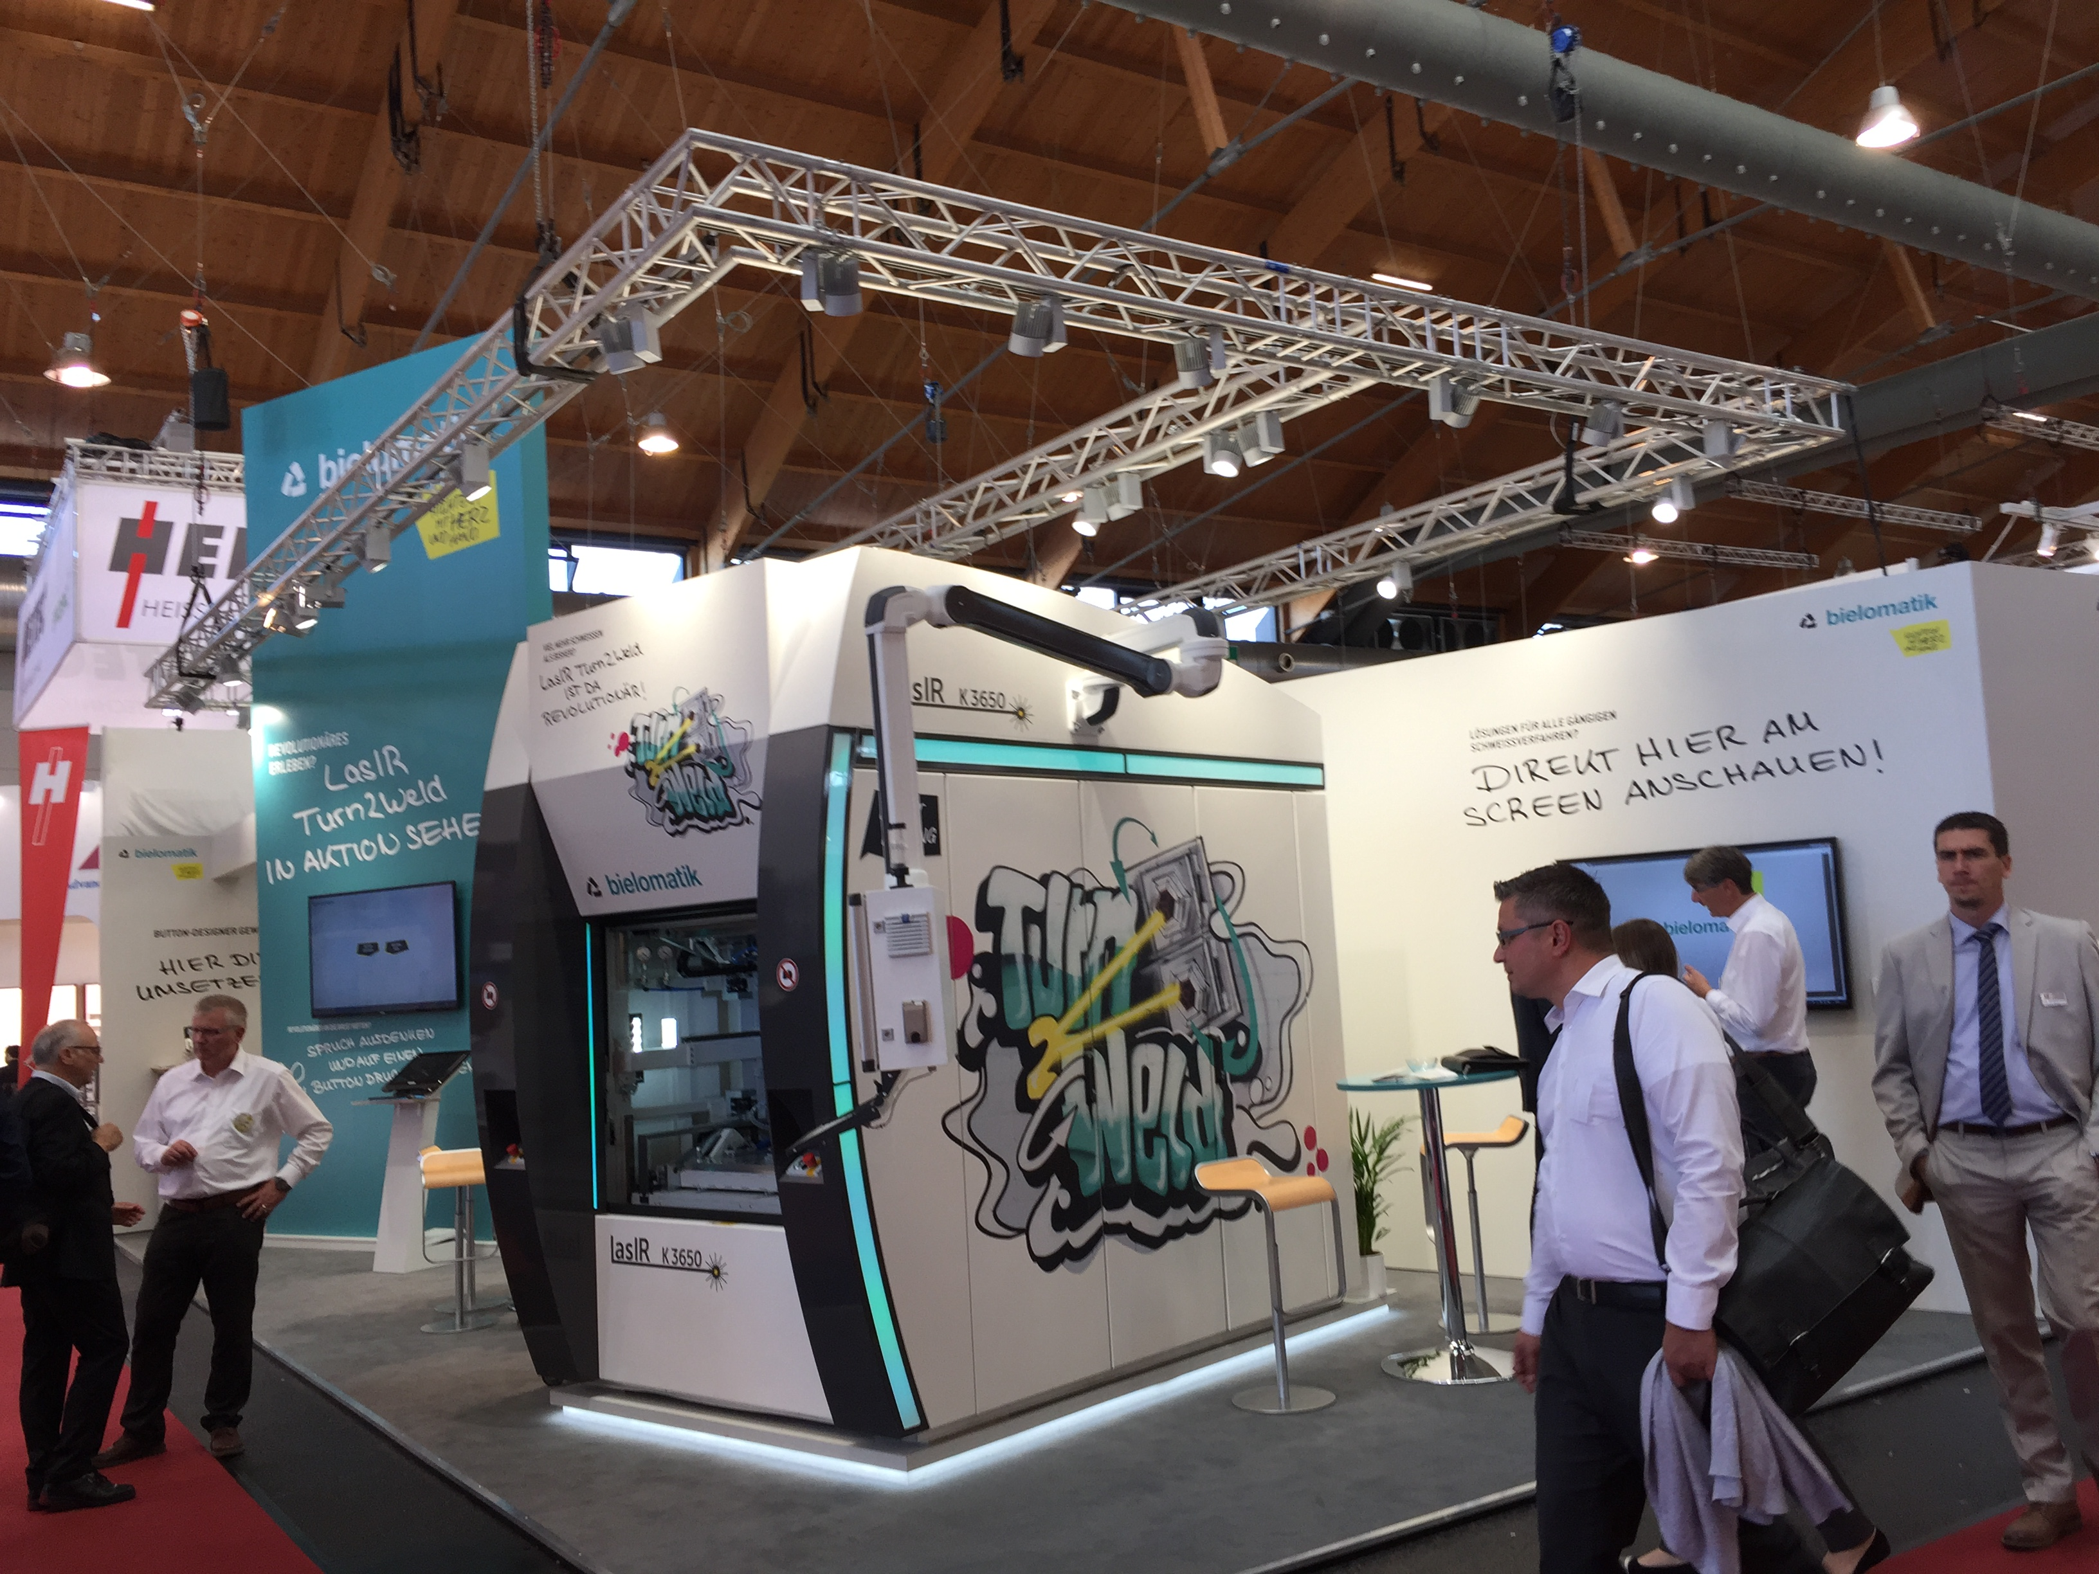

caption: Fakuma 2017

