Automotive World Tokyo, January 18th – 20th 2017

bielomatik review: Trade fair follow-up Automotive World.

There’s no better way of getting to know the automotive sector in Japan than with the help of this 3-day crash course. At the Automotive World, you can glean insights into automotive electronics, technologies for EV/HEV, connected cars, lightweight and component processing in more than 10 halls. At bielomatik, we were of course busy getting in touch with new customers, too. And for that there is ample opportunity: According to estimates of both of our trade-fair representatives, the fair sports the highest density of engineers per square meter. Dr. Michael Hager and Mesut Coskun from bielomatik Lubrication were able to discuss with representatives from the most important automotive brands. As a souvenir, they brought with them some very promising contacts. Before that, Dr. Michael Hager additionally invested into the bielomatik fame by speaking on the topic ‚MQL’.

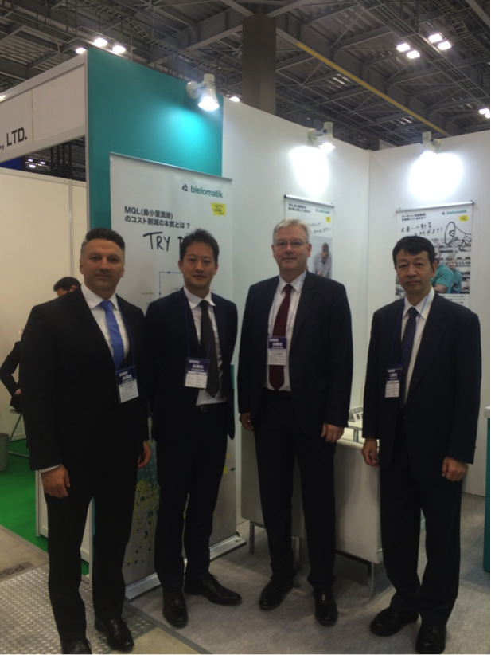

The trade fair team (from left): Mesut Coskun, Tomohiro Tokukura, Dr. Michael Hager, Hachiro Kano (picture bielomatik)

bielomatik Leuze GmbH + Co. KG
Daimlerstraße 6-10
72639 Neuffen
Phone: +49 7025 / 12-0
www.bielomatik.com

Questions, versions / links to:
Carolin Nuffer
Marketing Lubrication Technology
Phone: +49 7025 / 12-478
Carolin.Nuffer@bielomatik.de

