bielomatik: Minimal Quantity Lubrication (MQL) for advanced drilling units
_________________________________________________________________________________
Nagging questions solved
Together with an aircraft manufacturer, bielomatik Leuze has solved drilling problems: A portable device for environmentally compatible minimal quantity lubrication was developed especially for the direct use with automatic advanced drilling units.

It is only three letters but they tell experts: Someone has considered the environment and the costs for machining. I am referring to MQL (minimal quantity lubrication), a specialty of bielomatik Leuze GmbH + Co. KG from Neuffen, Germany: MQL protects the environment during drilling, thread cutting, reaming and grinding, saves money and produces dry, directly recyclable waste chips. Many machine tool spindles have already been equipped with MQL from Neuffen: The systems are used in the automotive industry, by its suppliers, in machinery construction and other industries. To be precise, bielomatik Leuze offers one- and two-channel systems and the "MQL 2 plus" with additional water supply for cooling via a special fluid unit, which has already been introduced in 2014.
Based on this success, the "Mobile Lubrication Unit (MLU)" was developed especially for use in the aerospace industry. It was proposed by an aircraft manufacturer who also supported the Swabian company during development. The mobile device can be directly connected to all commercially "Advanced Drilling Units" (ADU). A specific challenge is presented by the typical sandwich materials titanium, CFRP and aluminum which are currently used in aircraft construction. "If the device is adapted to the relevant ADU and the process is perfectly set and tested, the CFRP should remain dry," explains Marcel Schlierer, designer at bielomatik. In addition, the aircraft manufacturer emphasized that this unit should be easy to handle. It was supposed to make the life of the workers easier and immediately alert them to any occurring errors.

Correspondingly, the result was an ergonomic solution: At the beginning of each shift, the worker fills the removable 1 l cartridge tank at a fueling station with its fluid supply, which is monitored by a control system in the MLU during the shift. Alternatively, an empty tank can be exchanged for a full tank. The electronic system also checks the battery capacity. It warns via LED display if the fluid supply or the electric energy is running low. Schlierer: "If, for example, fluid supply or battery capacity decreases to 20%, the LED will start flashing. Starting from 15%, the worker is warned by a continuous LED signal.
The MLU system starts by manually operating the start button, by switching on the ADU which is usually operated using signal air or with the help of an SPS signal (24 V): air and oil (5 ml to 500 ml/h; 8 bar air pressure) flow through separate channels of a hose with a length of around 5 m to a so-called mixing chamber which produces a spray which is then mixed with additional air upstream of the ADU. The MLU system with a weight of approx. 6 kg can either stand on the floor or it can be attached to mounting devices with the help of strong magnets.

The unique selling point is the special control system using which the MLU automatically switches the MQL process on and off and in this way individually adapts to the relevant material requirements. "Via a time control, the oil flow is shut off when passing through the CFRP layer and with a perfect process setting the drilling site remains dry," explains the designer. "In shift operation, the foreman for example programs the MLU by imaging the process on the computer using a table. The material and its thickness are entered, for example." Then the required processing time is calculated automatically. Subsequently, the program is uploaded to the device which is protected against manipulations by unauthorized persons by a security code. Instructions regarding programming and handling will be provided by bielomatik employees.

After initial tests with prototypes together with a tool manufacturer, the feedback was very promising not only in the aerospace industry. Schlierer: "bielomatik has already received requests – for example by band saw manufacturers – for simple applications with external MQL. The mobile device is planned for series production as well as for retrofitting.

EMO 2017: Hall 6, Booth H15

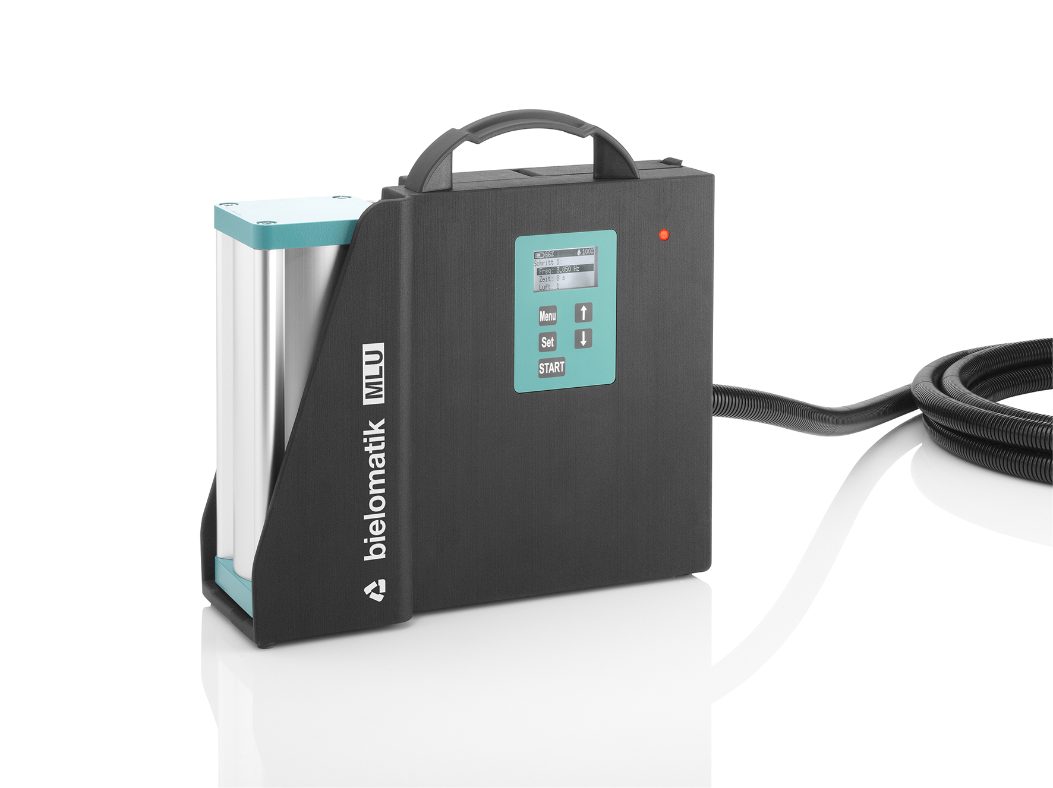
A clean job: With the support of an aircraft manufacturer, a "Mobile Lubrication Unit (MLU)" for minimum quantity lubrication (MQL) during drilling with "Advanced Drilling Units (ADU)" was developed. Image: bielomatik

bielomatik Leuze GmbH + Co. KG
Daimlerstraße 6-10
72639 Neuffen
Phone: +49 7025 / 12-0
www.bielomatik.com

Questions, versions / links to:
Carolin Nuffer
Marketing Lubrication Technology
Phone: +49 7025 / 12-478
Carolin.Nuffer@bielomatik.de

